AI ACCEPTABLE USE –
Student Friendly Version

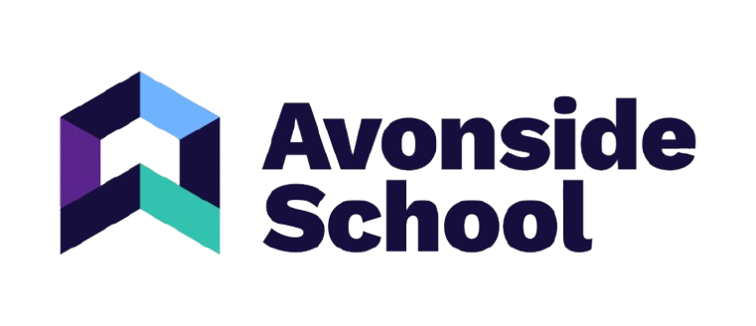
🤖 AVONSIDE SCHOOL
AI ACCEPTABLE USE
Your guide to using Artificial Intelligence safely and responsibly

🌟 What is AI?
AI means Artificial Intelligence.
AI is technology that can do things that normally need human thinking.
For example, some AI tools can:
💬 Answer questions
✍️ Help create text
🎨 Create pictures
🎵 Create music
💡 Give you ideas
🔎 Find or organise information
💻 Help with computer tasks
Generative AI can create new text, images, audio, video or computer code.
AI can be really useful for learning — but it also has risks.
Our aim is to help you become a safe, responsible and smart user of AI.

🟢 AI CAN HELP YOU LEARN
With your teacher's permission, AI might help you:
💡 Think of ideas
📝 Plan an answer
🎭 Practise role play
📚 Understand a difficult topic
🧩 Break a task into smaller steps
💬 Explore different ways of explaining something
♿ Support your individual learning needs
Remember:
AI should HELP YOU LEARN.
It should NOT DO YOUR LEARNING FOR YOU.

🔴 SOME AI USE IS NOT ALLOWED
You must not use AI tools that the school has not approved.
🚫 Do NOT use:
Social media bots or chatbots
These can spread misinformation or allow inappropriate interactions.
Deepfake technology
Do not create or share fake videos, pictures or audio that could mislead or harm people.
AI homework/writing tools that do the work for you
You must not use AI to avoid doing your own learning or to submit work that is not really yours.

🧠 THINK BEFORE YOU USE AI
AI can make mistakes.
AI can sometimes:
- Give you information that is wrong
- Make something up
- Give you an unfair or biased answer
- Give you information that sounds convincing but isn't true
So remember:
🛑 STOP
Don't automatically believe what AI tells you.
🤔 THINK
Ask yourself: Does this make sense?
🔎 CHECK
Check important information with your teacher or another trusted source.

🔐 KEEP YOUR INFORMATION PRIVATE
Never put personal or private information into an AI tool unless your teacher has told you it is safe and allowed.
❌ Don't share:
🔑 Passwords
🏠 Your home address
📞 Phone numbers
📧 Personal email addresses
🎂 Personal details
📸 Private photographs
🏫 Private school information
👤 Other people's personal information
Remember:
🔒 KEEP IT PRIVATE.
KEEP IT SAFE.
Only use AI platforms that the school has approved.
The school's policy states that AI platforms used by pupils should not require or record pupils' personal data.

❤️ RESPECT OTHER PEOPLE
AI should be used in a way that is:
🤝 Respectful
Don't use AI to create things that bully, threaten or hurt someone.
🌈 Inclusive
Don't use AI to create discriminatory or hateful content.
🧠 Responsible
Think about how your use of AI could affect other people.
Everyone deserves to be treated fairly and with respect.

✍️ YOUR WORK SHOULD BE YOUR WORK
This is one of the most important rules.
You can use AI to help you learn...
But you must not:
❌ Ask AI to write your whole assignment.
❌ Copy an AI answer and pretend you wrote it.
❌ Submit AI-generated work as your own.
❌ Use AI to avoid doing the learning yourself.
This is called plagiarism or academic dishonesty.
The school expects pupils to produce original work and says AI-generated content used in academic work must be properly acknowledged.

💡 A GOOD WAY TO USE AI
❌ NOT OK
"Write my homework for me."
✅ BETTER
"Can you give me three ideas I could use to start my homework?"

❌ NOT OK
Copy an AI answer and hand it in.
✅ BETTER
Use AI to help you understand the topic, then write your answer yourself.

❌ NOT OK
"Do my whole project."
✅ BETTER
"Can you help me plan the different parts of my project?"

📝 YOUR TEACHER MAY ASK ABOUT YOUR AI USE
Sometimes your teacher may ask you to:
- Show the AI conversation you used
- Explain how you used AI
- Explain how you created your work
- Show your planning or drafts
This is not about trying to catch you out.
It helps your teacher understand your learning and how AI has been used.

🔍 WHAT IF A TEACHER THINKS AI HAS WRITTEN YOUR WORK?
Your teacher may compare your work with:
- Your previous work
- Your usual writing style
- Your known ability
- Your explanations of the work
You will have an opportunity to talk to your teacher and explain how you created your work.
If there are concerns, the school may investigate further.
If AI misuse is confirmed, the response will follow the school's academic integrity and disciplinary procedures. The policy says the focus should remain on helping pupils understand ethical research and the importance of original work.

🆘 WHAT IF SOMETHING GOES WRONG?
If you see something online or in an AI tool that:
😟 Worries you
😡 Upsets you
🚨 Makes you feel unsafe
❓ You don't understand
⚠️ You think breaks the rules
Tell an adult.
You can speak to:
👩‍🏫 Your teacher
🧑‍🏫 Your tutor
🛡️ A safeguarding lead
💻 The IT team
👨‍💼 Head of Digital Literacy
🏫 Another trusted adult
AI-related concerns can be reported to the DSL, Head of Digital Literacy or IT Department.

⭐ THE 6 GOLDEN RULES OF AI
1️⃣ ASK
Is AI allowed for this task?
2️⃣ CHECK
Could the information be wrong?
3️⃣ PROTECT
Keep personal information private.
4️⃣ THINK
Am I using AI to help me learn — or to do the work for me?
5️⃣ BE HONEST
If you use AI for schoolwork, follow your teacher's instructions about acknowledging it.
6️⃣ TELL
If something feels unsafe or wrong, tell an adult.

🤖 AI SHOULD BE YOUR TOOL — NOT YOUR SUBSTITUTE
Use AI to:
💡 Think
🔎 Explore
🧠 Learn
📝 Plan
🎨 Create
But always:
❤️ Think for yourself.

🌟 REMEMBER
AI can be powerful.
You are responsible for how you use it.
Be curious.
Be safe.
Be honest.
Be responsible.
🤖 USE AI SMART.
🧠 THINK FOR YOURSELF.
🌈 KEEP YOURSELF AND OTHERS SAFE.

